**Xiaomi announces Redmi 10: Reinventing the entry-level smartphone experience at all fronts**

PAKISTAN, August 30th – Xiaomi today launched Redmi 10 in Pakistan. Following up with a full suite of major upgrades compared with its predecessor, Redmi 10 touts the series’ first 50MP hi-res camera, 90Hz 6.5” FHD+ AdaptiveSync display, a powerful chipset and a sleek design, making exceptional performance available to more and more people.

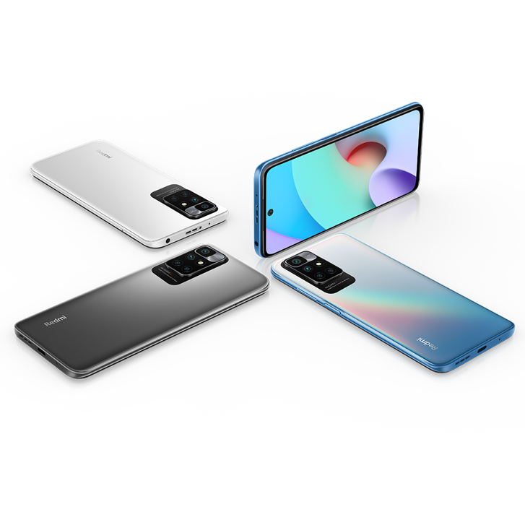

Redmi 10 comes packed with flagship-grade features for a smartphone of this caliber to deliver performance that exceeds expectations. The value of Redmi 10 offers speaks for itself. Its outstanding 50MP camera for high-res shots is a first of its kind in its category, making cutting-edge photography accessible to all. But it also boasts a 90Hz refresh rate and high-performance hardware, making Redmi 10 a top-of-the-line contender in its bracket.



**Reinvent the entry-level smartphone experience with a killer camera and display**

Redmi 10’s 50MP ultra-high resolution main camera captures amazing content with stellar details. Accompanied by a 8MP ultra-wide camera, 2MP macro camera, and a 2MP depth sensor, Redmi 10 gives you the freedom to capture moments in all situations. The device also packs a suite of stylish filters to add flair for your shots, as well as panorama selfies ideal for large group shots that get you and all your friends in the picture.

Looking at its display, Redmi 10 comes with a large 6.5” screen with FHD+ resolution, while a 90Hz refresh rate for seamless scrolling and swiping is a treat for your eyes. Paired with AdaptiveSync technology, Redmi 10 automatically adjusts refresh rate to your content, keeping your battery alive longer as it’ll boost refresh rates for only those moments when you actually need it. In addition, Redmi 10 features Reading Mode 3.0 to relax your eyes as you flip through your favorite content.

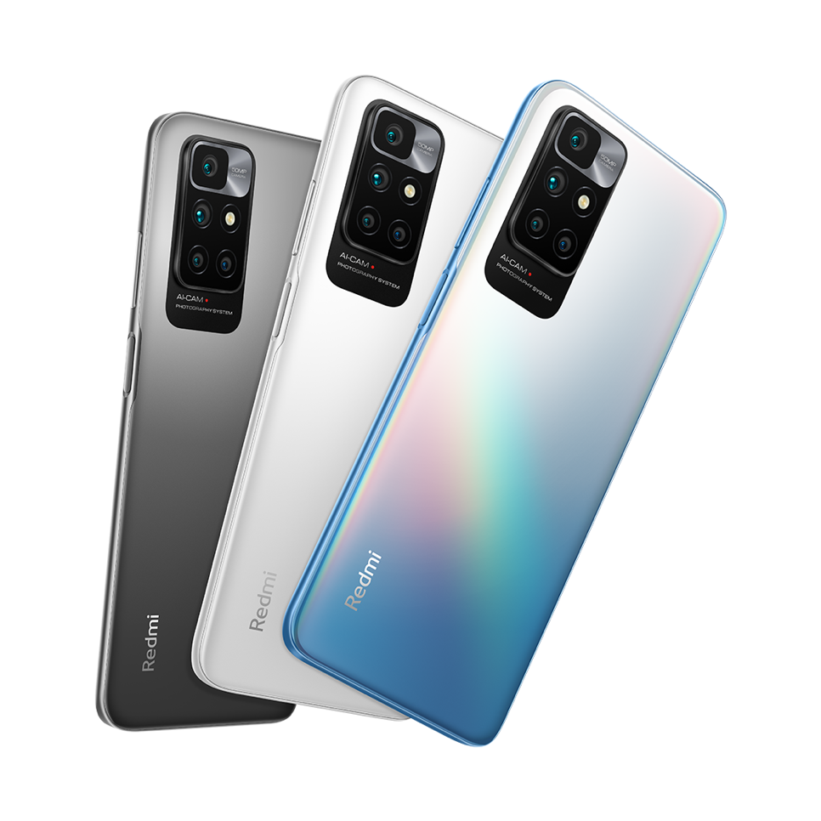

**Next-level experience showcased in a sleek and stylish design**

Powered by a 2.0GHz octa-core MediaTek Helio G88 processor, Redmi 10 is designed from the ground up to perform. Utilizing a lightning-fast GPU, Redmi 10 takes your mobile performance to a whole new height with powerful hardware and next-level features. With a massive 5,000mAh battery, 18W fast charging, and an in-box 22.5W charger, Redmi 10 helps you sail through your tasks without worry.

Redmi 10 has a sleek and stylish design that’s smooth to the touch and a joy to behold. It’s available in 3 beautiful colors; matte Carbon Gray and Pebble White with a classic, smooth fingerprint-proof finish, and a beautifully textured glossy Sea Blue. In addition, Redmi 10 comes with MIUI 12.5 out of the box, and offers an immersive audio experience with its dual speakers.

Redmi 10 comes in two variants - 4GB+128GB which will be available online exclusively at Mistore.pk, Daraz.pk and Airkart.com.

The other variant, 6GB+128GB will be available exclusively offline at Xiaomi Stores.

Both will be available for purchase via Xiaomi’s official sales channels mentioned above from August 30th. Prices start at PKR 29,999 & PKR 32,999.

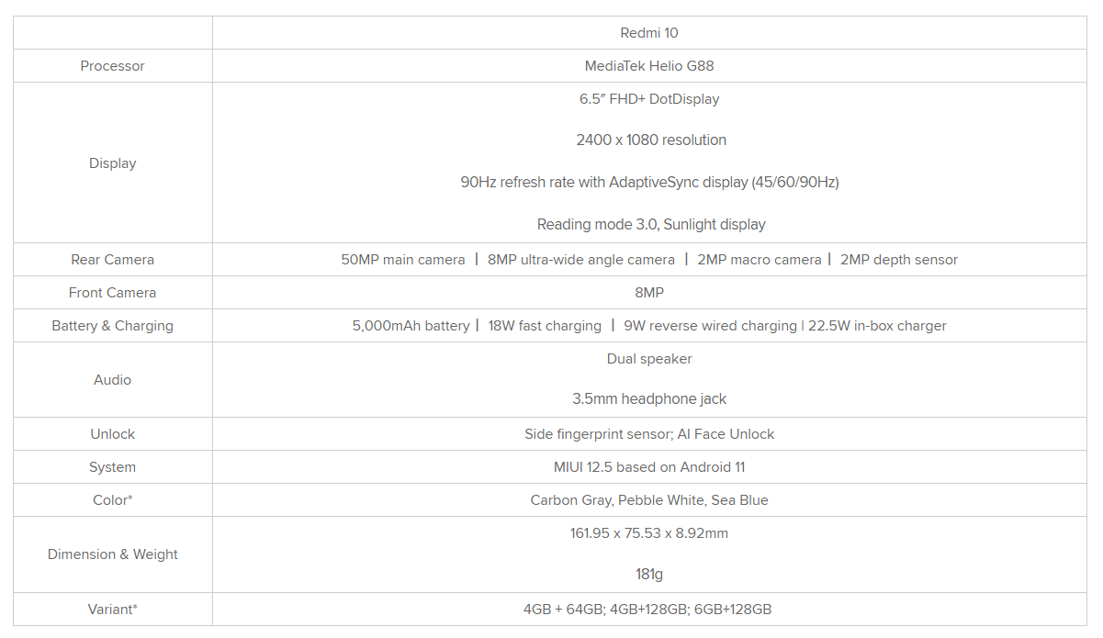

*Availability may vary between markets.

**About Xiaomi Corporation**

Xiaomi Corporation was founded in April 2010 and listed on the Main Board of the Hong Kong Stock Exchange on July 9, 2018 ([1810.HK](http://1810.hk/)). Xiaomi is a consumer electronics and smart manufacturing company with smartphones, smart hardware and Internet of Things (IoT) platform at its core.

With an equal emphasis on innovation and quality, Xiaomi continuously pursues high-quality user experience and operational efficiency. The company relentlessly builds amazing products with honest prices to let everyone in the world enjoy a better life through innovative technology.

As of the second quarter of 2021, Xiaomi is the No.2 smartphone brand in the global smartphone market. The company hasalso established the world’s leading consumer AIoT (AI+IoT) platform, with over 351.1 million smart devices connected to its platform, excluding smartphones and laptops. Xiaomi products are present in more than 100 countries and regions around the world. In August 2021, the company made the Fortune Global 500 list for the third time, ranking 338th, up 84 places compared to 2020.