**realme 8 Series Arrives in Pakistan with a Spectacular 108MP Ultra Quad Camera & Smart AIoT Products**

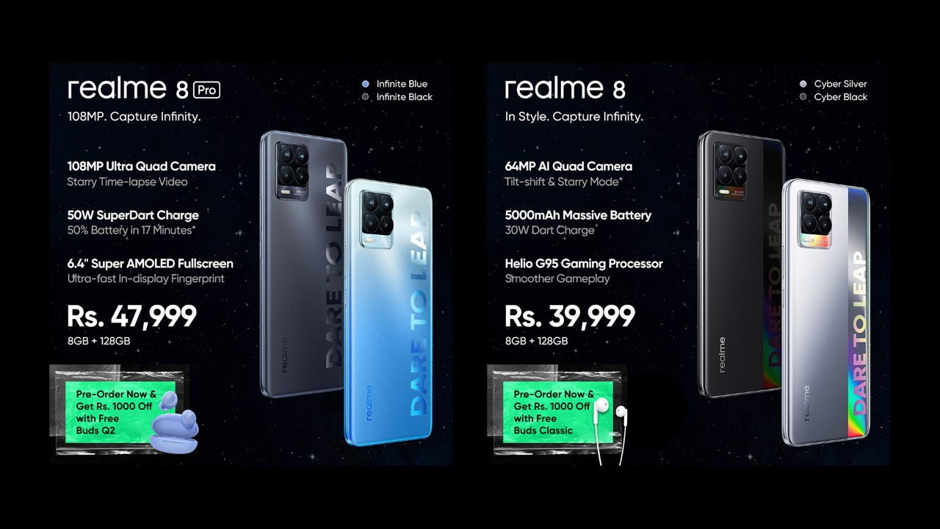

***People can pre-order the realme 8 Series starting from Wednesday, April 28, 2021 and grab exclusive pre-order bundles***

**Lahore – Wednesday, April 28, 2021:**realme, the world's fastest-growing smartphone brand, officially launched its realme 8 series in Pakistan. With a 108MP Ultra Quad camera and 50W SuperDart charge, the camera powerhouse realme 8 Pro debuts with the gaming beast realme 8 which comes with the MediaTek Helio G95 gaming processor and 5,000 mAh battery. The launch event was a star-studded affair featuring celebrities as realme Allies including acting superstar, Kinza Hashmi, the famous fashion photographer Azeem Sani, tech sensation Bilal Munir of VideoWaliSarkar, and our very own pro-gamer Saad-ur-Rehman AKA Ducky Bhai.

The number series is realme’s most popular smartphone series globally with more than 30 million users. Over the years, six generations of the realme number series have been a democratizer of flagship technology for the youth, bringing premium features at affordable price points. The latest successor, the realme 8 Series brings incomparable smartphone specifications. The all new realme 8 Pro comes with a 108MP Ultra Quad Camera and a series of groundbreaking photography features. It supports the new Samsung 1/1.52 inch HM2 108MP sensor providing a maximum resolution of 12000×9000 for ultra-sharp picture quality. Other features include a Super AMOLED display, 50W SuperDart Charge, 4,500mAh battery, and Qualcomm Snapdragon 720G Mobile Platform.

Another variant in the series, the realme 8 comes with a 64MP AI Quad Camera with smart sensors for sharper photos, and better night image quality. But, the real deal in realme 8 is the MediaTek Helio G95 gaming processor that will make it a favorite with gamers. It gives a seamless gaming performance, which coupled with the 5,000 mAh battery and 30W Dart Charge goes on better and longer. Both smartphones have a 6.4-inch Super AMOLED Fullscreen Display and have an 8GB + 128GB storage setup.

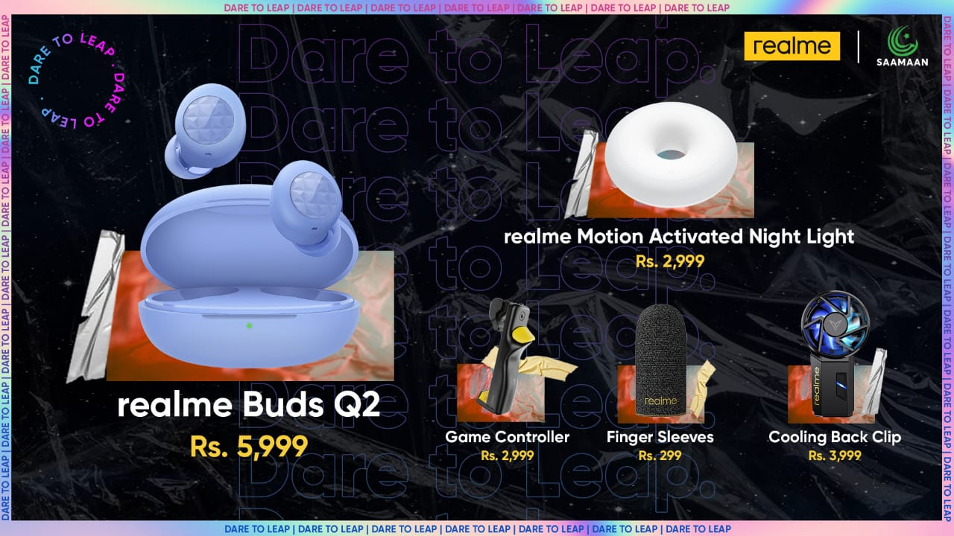

On the smart AIoT front, realme also introduces a one-of-a-kind range of smart audio and smart home products. The series launches with the next generation realme Buds Q2 that comes packed with 20 hours of long battery life, Bass Boost+ driver, Gaming mode, Smart touch functions, and more. Another great device is the realme Motion Activated Night Light with infrared motion sensors that doesn’t let a move go in the dark.

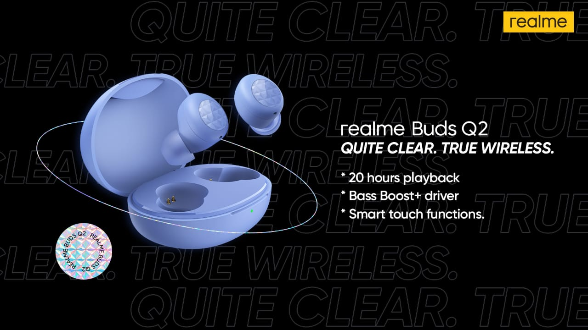

But the most exciting AIoT device is the realme Gaming Pro Kit that features a Cooling Back Clip, Gaming Controller and Mobile Game Finger Sleeves. The realme Gaming Pro Kit will be a hit with pro-gamers and open new frontiers in their gaming adventures.

The realme 8 Series can be pre-ordered from Daraz.pk with exciting bundles. People can pre-order the realme 8 Pro for PKR 47,999/- from Wednesday, April 28 to Friday, May 07, 2021 and get a realme Buds Q2 absolutely free.

The realme 8 can be pre-ordered for PKR 39,999/- from Wednesday, April 28 to Tuesday, May 04, 2021 along with a realme Buds Classic absolutely free. The AIoT devices will be exclusively available at Saamaan.pk from Wednesday, May 05, 2021 onwards.

---End---

For more information, please go to [www.realme.com](http://www.realme.com/).

**About realme**

realme is a technology brand that provides leapfrog quality and trendsetting smartphones and AIoT products to the global market. realme users are young and globally-minded. realme products empower young people to ‘Dare to Leap’ using the latest technology and design.

realme is the 7th top smartphone brand in the world and was recognized as one of the mainstream smartphone brands according to [Counterpoint’s statistics](https://www.counterpointresearch.com/huawei-surpassed-samsung-become-number-one-global-smartphone-shipments-q2-2020/) of global smartphone shipments in Q3 2020. In 2019, realme’s global smartphone shipments reached 25 million with a YoY growth rate of 808%, making realme the fastest-growing smartphone brand in the world for four consecutive quarters from 2019 to Q2 2020. realme has entered 61 markets worldwide, including China, Southeast Asia, South Asia, Europe, Russia, Australia, the Middle East, Africa with a global user base of over 70 million.