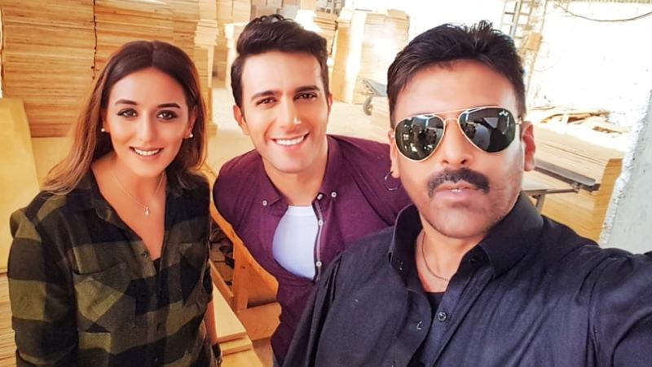

Web series is all the rage today- more and more actors from the industry are seen experimenting with the new found medium. *Mind Games* is another series we should all look forward to. “It’s an international series that potentially will go on Netflix Canada”, shares Shamoon Abbasi with DailyTimes Newspaper. ”It is directed by Farhan Tajammul, produced by Imran Tajammul, under the banner of Picture Wala Production Canada” talking about the cast he adds, “Cast includes me, Emmad Erfani, Sana Fakhar, Kanza Razzaq and more. It’s shot on red camera and the partial shooting will happen in Canada”



*Mind Games* is about money laundering through models in Pakistan, based on true events. Shamoon Abbasi is known for his selection of versatile roles-the different storyline convinced the actor to get on board. "As you know, I like to do projects based in reality rather than fantasy stories. The plot of this series is based on some true events, and is partially about money laundering done via models from Pakistan. That part intrigued me and I wanted to get more involved; the character that I'm playing is part of that gang that does all this business. There are a few complications, things go awry and then the story revolves around the protagonist, the cop played by Emmad Irfani” explains Abbasi.

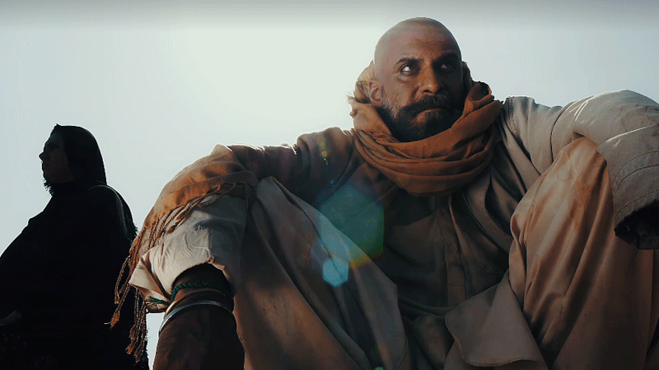

We also talked to the actor about his upcoming movie ‘Durj’, the movie will be a mystery thriller, based on Cannibalism in Pakistan. The script is written and directed by Shamoon Abbasi and Produced by Dodi Khan- speaking about his extreme character, the actor states: “It took me around a year to get to work on the character and the whole look. I had to say no to many projects; meanwhile, the target was to get closer to the character by feeling the way such people live and survive.”

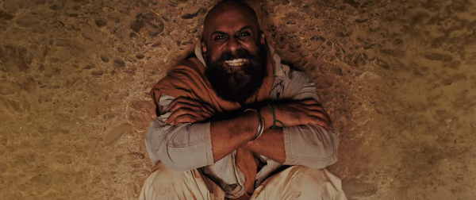

Revealing some exclusive details, he also tells DT,” Sherry Shah went bald in the film and you will see a scene in the movie where her head is being shaved.” Sherry certainly went extreme and over board for her role in ‘Durj’- Sherry’s pictures went viral over the internet- it is evident how the model has displayed some serious acting skills. The trailer is terrifying- certainly not for the weak hearted!

“Myra khan has worked very hard in the movie with loads of action and mountain climbing! The research was the hardest part of the film as these were real cases that happened around Pakistan and collecting the data and converting it into a movie was a challenge. But now that the trailer is out viewers are anxious to watch Durj around the globe.” DURJ is going to be part of Cannes Film Festival. Shamoon Abbasi says,” The film will be out on Eid hopefully!”